CRYPTOGYAPHY AND NETWORK SECURITY ALA:3
Social Engineering Attacks
and Major Security Breaches in India
A simple-English case-study report

Student | Vikram Vaghela
College | Gyanmanjri Innovative University (GMIU)
Subject | Cryptography and Network Security
Enrollment | 241105060143

Academic note This report separates confirmed facts from allegations and does not treat an incident’s attack method as social engineering unless the evidence supports that label.

Contents and reading guide
- Introduction and key attack techniques
- How a cyberattack commonly unfolds
- Five India-linked case studies
- Comparison table
- Prevention strategies
- Incident-response flowchart
- Conclusion and references

How to read the evidence
The five cases were selected because they are widely reported and useful for comparing different kinds of cyber incidents. A malware-based banking attack, a ransomware incident, a third-party data breach, an alleged e-commerce exposure, and a disputed Aadhaar access story are not the same event. The report therefore uses careful labels such as confirmed, reported, potential, or allegation.
Source practice Amounts, dates, affected systems and recovery statements are included only where a cited source reports them. “Not publicly confirmed” means the public record reviewed here did not establish a reliable figure.

1. Introduction
Cybersecurity is the practice of protecting computers, networks, applications and data from misuse, damage or unauthorized access. Social engineering is different from a purely technical attack: it targets people and their decisions. An attacker may pretend to be a bank employee, create urgency, offer a fake reward or ask someone to click a harmful link.
Many real incidents combine human and technical weaknesses. For example, a stolen password may give access to a system, and malware may then move through that system. The correct classification matters because prevention must address both technology and behaviour.

2. Common social-engineering and cyberattack techniques
Technique | Simple meaning and example
Phishing | A fake email, text or website tries to steal a password or payment detail. Example: “Your account will close today—sign in here.”
Spear phishing | A targeted message uses personal or workplace information to appear believable.
Pretexting | The attacker invents a story or identity, such as a fake auditor asking for an employee code.
Baiting | A tempting offer or free item encourages unsafe action, such as plugging in an unknown USB drive.
Quid pro quo | The attacker promises a benefit, service or refund in exchange for information.
Tailgating | A person follows an authorized employee into a restricted area.
Credential theft | Passwords, session tokens or one-time codes are captured or reused.
Malware | Malicious software changes, spies on or damages a system. It may arrive through a link, attachment or vulnerable service.
Ransomware | Malware locks or encrypts data and demands payment. It is a technical attack; social engineering may be one way it enters.
Software vulnerability | A flaw in an application or system is exploited. This is a technical weakness, not automatically a social-engineering attack.

3. How an attack commonly unfolds
Message or access point | Trust or mistake | Credentials / malware | Unauthorized access | Data or money stolen

This flow is a teaching model, not a claim that every incident followed the same sequence. In a technical breach, the first step may be an exposed service or vulnerable software rather than a message to a person.

Case Study 1: Cosmos Bank cyberattack (2018)
Evidence status Confirmed cyber-fraud reporting; exact full recovery amount and complete recovery duration were not publicly confirmed.

A. Case name and year
Cosmos Bank cyberattack — 2018.

B. History/background
Cosmos Bank, a Pune-based cooperative bank, reported a two-part cyber fraud in August 2018. Card data was used for coordinated ATM withdrawals in multiple countries, and a separate SWIFT-related transfer was sent to a Hong Kong-based account. The public reporting describes the event as a malware and payment-system compromise rather than a proven phishing attack.

C. Attack type and technique
ATM-switch malware, cloned-card transactions and fraudulent SWIFT transfer. This is primarily a technical and payment-fraud incident, not a confirmed social-engineering case.

D. How the attack happened
- Attackers compromised information connected to the bank’s card-processing environment.
- They used stolen card data to create or use cloned cards.
- Thousands of cash withdrawals were made across many ATMs in a short period.
- A separate transfer was initiated through the bank’s SWIFT environment to Hong Kong.
- Investigators traced part of the transferred money to Macau; later reporting described arrests and convictions
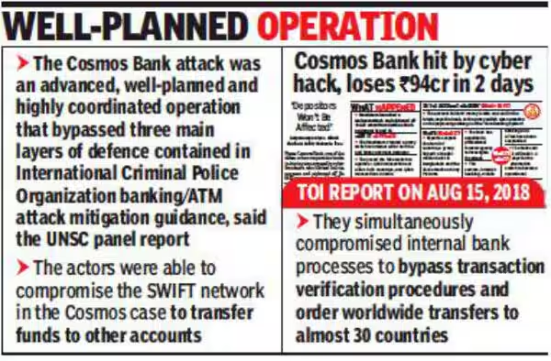.

E. Original article photograph or official-report visual
[ ORIGINAL ARTICLE VISUAL / SOURCE PLACEHOLDER ]
A legally retrievable original news photograph was not embedded. The linked Reuters report includes a clearly labelled illustrative file image; the court-report link is provided for verification.
Reuters / The Hindu. “Cosmos Bank loses $13.5 million in cyber attack; Pune court convicts 11 accused.” 2018–2023. Open source article/report

F. Impact
Reported losses were about ₹94.42 crore, including ₹80.50 crore through 14,849 card transactions and about ₹13.92 crore through the transfer route. The bank stated that customer accounts themselves were safe, but the bank and payment systems were affected.

G. Financial loss/cost
The reported principal loss was approximately ₹94.42 crore. Recovery of the full amount was not publicly confirmed in the sources reviewed; The Hindu reported that ₹5.72 crore of the Hong Kong transfer was recovered.

H. Recovery time
Cash withdrawals and transfer activity occurred over two days in August 2018. A full restoration duration for all systems was not publicly confirmed.

I. How the incident was discovered
The bank detected the unusual transactions and filed a police complaint; the case then became the subject of police investigation, RBI examination and court proceedings.

J. Response and solution
- The bank reassured customers and investigated the attack.
- Police investigated the ATM and SWIFT paths and arrested suspects.
- RBI officials examined the bank’s IT robustness and the damage.
- A court later convicted 11 accused in the fraud case.

K. Prevention
- Segment ATM, card-switch and SWIFT environments.
- Use transaction velocity checks and geographic anomaly detection.
- Require independent approval for high-risk international transfers.
- Use hardware-backed keys, privileged-access monitoring and tested response playbooks.

L. Lessons learned
- Payment systems need controls that can stop abnormal speed and geography.
- A secure customer account does not mean the bank’s processing layer is safe.
- International transfers need independent verification.
- Fast containment limits the value of a coordinated cash-out.

M. Sources
- Reuters — Cosmos Bank loses $13.5 million in cyber attack — https://www.reuters.com/article/world/cosmos-bank-loses-135-million-in-cyber-attack-idUSKBN1KZ1J8/
- The Hindu — Pune court convicts 11 accused in Cosmos Bank cyber fraud case — https://www.thehindu.com/news/national/other-states/pune-court-convicts-11-accused-in-cosmos-bank-cyber-fraud-case/article66769928.ece
- Times of India — Cosmos Bank hit by cyber hack, loses Rs 94 crore in 2 days — https://timesofindia.indiatimes.com/city/pune/cosmos-bank-hit-by-cyber-hack-loses-rs-94-crore-in-2-days/articleshow/65409441.cms

Case Study 2: AIIMS Delhi ransomware incident (2022)
Evidence status Confirmed ransomware and service-disruption reporting; initial access and complete restoration date were not fully established in the cited sources.

A. Case name and year
AIIMS Delhi ransomware incident — 2022.

B. History/background
On 23 November 2022, the All India Institute of Medical Sciences (AIIMS), New Delhi experienced a ransomware attack that disrupted digital hospital operations. Government reporting said five servers were affected and about 1.3 terabytes of data were encrypted. Public sources describe improper network segmentation as a contributing weakness; the attacker’s initial entry method was not publicly established in the cited government answer.

C. Attack type and technique
Ransomware and network-compromise incident. It should not be labelled phishing or social engineering without evidence of a deceptive message or human manipulation.

D. How the attack happened
- Threat actors gained access to parts of the AIIMS IT network.
- Poor network segmentation allowed the compromise to affect critical applications.
- Files and data on affected servers were encrypted.
- Hospital services such as registration, billing and laboratory workflows moved to manual processes.
- CERT-In and other stakeholders assessed the incident and advised remedial measures.

E. Original article photograph or official-report visual
[ ORIGINAL ARTICLE VISUAL / SOURCE PLACEHOLDER ]
The Hindu article includes an AP photograph, but it was not embedded here because the licensing status does not clearly permit reuse in a student assignment. The linked government PDF is the authoritative companion source.
The Hindu / Government of India. “1.3 TB data encrypted and five servers affected in AIIMS ransomware attack.” 16–17 December 2022. Open source article/report

F. Impact
Five servers were affected and approximately 1.3 TB of data were encrypted, according to the Minister’s written response reported by The Hindu. Patient-care operations continued, but many digital workflows were disrupted and manual queues increased.

G. Financial loss/cost
No reliable public total cost or ransom payment was confirmed in the sources reviewed. Reports stated that the government did not pay the ransom.

H. Recovery time
AIIMS restored its e-data after about six days according to Times of India, while online services and network sanitisation took longer. The precise date when every service was fully restored was not publicly confirmed in the reviewed sources.

I. How the incident was discovered
AIIMS informed authorities; an FIR was registered, CERT-In carried out an evaluation, and the incident was investigated by multiple agencies.

J. Response and solution
- The hospital shifted essential work to manual processes.
- CERT-In and other stakeholders evaluated the incident and issued remedial advice.
- Systems were sanitised and data was restored from available sources.
- Staff were instructed to install updated antivirus protection and follow new procedures.

K. Prevention
- Use strong network segmentation between clinical, administrative and backup systems.
- Maintain offline and immutable backups and test restoration.
- Apply least privilege, MFA and endpoint monitoring.
- Practice downtime procedures so patient care can continue safely.

L. Lessons learned
- Resilience is part of patient safety.
- Backups are useful only when restoration has been tested.
- Segmentation limits blast radius.
- Manual fallback procedures should be rehearsed before a crisis.

M. Sources
- The Hindu — 1.3 TB data encrypted and five servers affected in AIIMS ransomware attack — https://www.thehindu.com/news/national/13-tb-data-encrypted-in-ransomware-attack-on-aiims-by-unknown-threat-actors-centre/article66271226.ece
- Government of India — Lok Sabha answer on cyber-attack in AIIMS — https://sansad.in/getFile/loksabhaquestions/annex/1710/AU1837.pdf
- Times of India — AIIMS restores data, online services to take time to resume — https://timesofindia.indiatimes.com/india/aiims-restores-data-online-services-to-take-time-to-resume/articleshow/95865392.cms
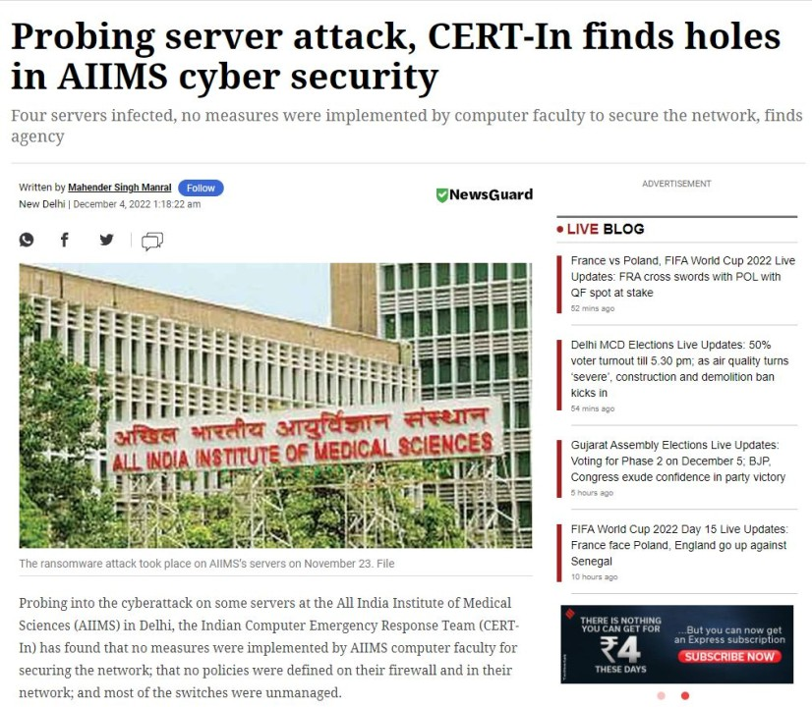

Case Study 3: Air India passenger data breach (2021)
Evidence status Confirmed public disclosure of a third-party cyberattack affecting Air India passenger records; attacker identity and recovery cost were not confirmed.

A. Case name and year
Air India passenger data breach — 2021.

B. History/background
Air India disclosed in May 2021 that a cyberattack at SITA, its passenger service system provider, affected approximately 4.5 million passengers worldwide. The affected records covered passengers registered over a long period, including personal, passport, ticket and frequent-flyer information. Air India said CVV/CVC numbers were not held by the processor.

C. Attack type and technique
Third-party supplier compromise / data breach. The public reporting does not establish phishing, pretexting or another social-engineering technique as the cause.

D. How the attack happened
- SITA, a data processor used by airlines, suffered a cyberattack in February 2021.
- Air India was notified and later received more detail about the affected data.
- Passenger records from the relevant historical period were identified as exposed.
- Air India secured affected servers, investigated with external specialists and advised password changes.

E. Original article photograph or official-report visual
[ ORIGINAL ARTICLE VISUAL / SOURCE PLACEHOLDER ]
The linked reports include publisher-owned news images or file photographs, but they were not embedded because reuse rights were not clearly available. Source links and captions are retained.
Reuters / BBC News. “Air India says February’s data breach affected 4.5 mln passengers.” 21–22 May 2021. Open source article/report

F. Impact
Names, dates of birth, contact details, passport information, ticket information and frequent-flyer data were involved. Air India said no password data was affected and that CVV/CVC numbers were not stored by SITA.

G. Financial loss/cost
Not publicly confirmed. The public reports reviewed describe the breach and response but do not establish a verified Air India recovery-cost total.

H. Recovery time
The incident was first reported to Air India by SITA in February 2021; the full scope was communicated in stages. A complete technical recovery duration was not publicly confirmed.

I. How the incident was discovered
SITA notified Air India about the cyberattack. Air India investigated and issued a public notification in May 2021.

J. Response and solution
- Air India secured compromised servers and engaged external cybersecurity specialists.
- The airline notified affected passengers and encouraged password changes.
- The airline continued to investigate the third-party incident and data scope.

K. Prevention
- Perform supplier security assessments and require rapid incident notification.
- Minimise data stored by processors and separate sensitive fields.
- Use MFA, strong password policies and monitoring for customer accounts.
- Maintain a clear third-party breach communications plan.

L. Lessons learned
- A supplier can become the route to a major customer-data incident.
- Data minimisation reduces harm.
- Breach notification may occur in stages as investigations mature.
- Passengers need clear, practical protective advice, not only a technical explanation.

M. Sources
- Reuters — Air India says February’s data breach affected 4.5 mln passengers — https://www.reuters.com/world/india/air-india-says-februarys-data-breach-affected-45-mln-passengers-2021-05-21/
- BBC News — Air India cyber-attack: Data of millions of customers compromised — https://www.bbc.com/news/world-asia-india-57210118
- TechCrunch — Air India passenger data breach reveals SITA hack — https://techcrunch.com/2021/05/23/air-india-passenger-data-breach-reveals-sita-hack-worse-than-first-thought/
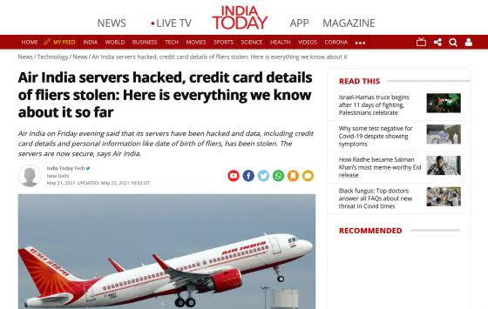

Case Study 4: BigBasket potential data breach (2020)
Evidence status Potential or alleged exposure; company was evaluating authenticity and extent. It is not presented as a fully proven breach of all claimed records.

A. Case name and year
BigBasket potential data breach — 2020.

B. History/background
In November 2020, cybersecurity firm Cyble reported that a database allegedly belonging to BigBasket had been offered for sale on a cybercrime market. The company said it was evaluating the claim, checking authenticity and had filed a police complaint. This case is included as a documented potential exposure, not as an unqualified proven breach of every claimed record.

C. Attack type and technique
Potential database exposure / credential and personal-data risk. The public sources reviewed do not prove that phishing, pretexting or baiting caused the incident.

D. How the attack happened
- Cyble found a database offered in a cybercrime market and investigated the sample.
- The firm reported that the data appeared to include names, emails, phone numbers, addresses, dates of birth and password hashes.
- Cyble informed BigBasket and later publicised the finding.
- BigBasket filed a complaint and began evaluating the authenticity and extent of the claim.

E. Original article photograph or official-report visual
[ ORIGINAL ARTICLE VISUAL / SOURCE PLACEHOLDER ]
No original article photo was embedded because the reports use file or stock imagery and reuse rights were not clearly available. The source links document the claim and the company response.
Business Standard / The Indian Express. “BigBasket faces potential data breach; details of 20 mn users put on sale.” 8–12 November 2020. Open source article/report

F. Impact
Cyble claimed that data for close to 20 million users was involved. The company said it did not store financial data such as credit-card numbers. Because the authenticity and full scope were under investigation, the report should be read as a potential exposure.

G. Financial loss/cost
The alleged data was advertised for about US$40,000 or approximately ₹30 lakh, but that is the seller’s asking price, not BigBasket’s loss. A verified company loss or recovery cost was not publicly confirmed.

H. Recovery time
Not publicly confirmed. The public sources describe investigation and containment efforts, not a verified restoration period.

I. How the incident was discovered
Cyble detected and validated the sample before notifying BigBasket; the company then filed a complaint and investigated the claim.

J. Response and solution
- BigBasket filed a cybercrime complaint.
- The company consulted cybersecurity experts and evaluated the authenticity and extent.
- The company stated that it did not store financial card data and sought immediate containment.

K. Prevention
- Protect password hashes with modern, slow password hashing and salt.
- Monitor for leaked credentials and force resets when exposure is credible.
- Limit personal data collection and retention.
- Use database access monitoring, segmentation and tested incident-response procedures.

L. Lessons learned
- A reported leak needs verification before its scale is treated as fact.
- Asking prices on criminal markets are not the victim’s financial loss.
- Password hygiene still matters when passwords are hashed.
- Companies should communicate what is known, unknown and being investigated.

M. Sources
- Business Standard — BigBasket faces potential data breach — https://www.business-standard.com/article/companies/bigbasket-database-of-20-million-customers-hacked-120110800800_1.html
- The Indian Express — Explained: How big is the Bigbasket data breach? — https://indianexpress.com/article/explained/explained-how-big-is-the-bigbasket-data-breach-7026688/
- The Hindu — Bigbasket faces potential data breach — https://www.thehindu.com/business/Industry/bigbasket-faces-potential-data-breach-details-of-2-crore-users-put-on-sale-on-dark-web/article33056301.ece
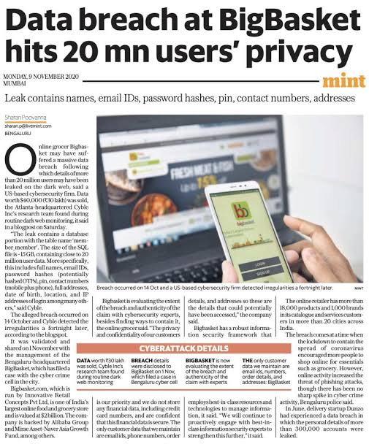

Case Study 5: Aadhaar data-exposure allegations (2018)
Evidence status Disputed allegation. UIDAI denied a biometric database breach; The Tribune and other reporting described unauthorized access to demographic lookup functionality.

A. Case name and year
Aadhaar data-exposure allegations — 2018.

B. History/background
In January 2018, The Tribune reported that an intermediary allegedly sold access to a search facility that returned Aadhaar-related demographic information. UIDAI denied that the core Aadhaar biometric database had been breached, described the incident as misuse of a grievance-redressal facility and said it had logging and traceability. This is therefore an allegation and access-control controversy, not a confirmed biometric-database breach.

C. Attack type and technique
Alleged unauthorized use of a grievance-redressal access facility and credential sharing. It is not accurate to call the event a proven breach of the biometric database.

D. How the attack happened
- The Tribune said a reporter paid an intermediary and received login details for a search facility.
- The report said demographic details could be retrieved using an Aadhaar number.
- UIDAI said the facility was limited, logged and intended for authorized personnel.
- UIDAI denied a biometric database breach and said legal action was being pursued.

E. Original article photograph or official-report visual
[ ORIGINAL ARTICLE VISUAL / SOURCE PLACEHOLDER ]
The linked BBC article credits a Getty image and the PIB release is text-only; no image was embedded because a reusable original visual was not legally clear. The disagreement is documented explicitly.
PIB / BBC News. “UIDAI denies media report and says Aadhaar data was not breached.” 4–5 January 2018. Open source article/report

F. Impact
The reported exposure concerned demographic information such as name and address; the sources disagree about the characterisation of the incident. UIDAI stated that biometric data remained safe and that the facility did not provide biometric access.

G. Financial loss/cost
Not publicly confirmed. The ₹500 payment described in reporting was an alleged access fee, not a verified loss suffered by UIDAI or citizens.

H. Recovery time
Not publicly confirmed. The sources reviewed discuss investigation and legal action, not a verified restoration period.

I. How the incident was discovered
The newspaper’s investigation brought the story to light. UIDAI issued a public denial, said it maintained logs and traceability, and reported that an FIR/legal action was being pursued.

J. Response and solution
- UIDAI denied a core biometric database breach and explained the intended purpose and limits of the facility.
- UIDAI said logs could support traceability and legal action.
- The Tribune defended its reporting and responded to UIDAI queries.

K. Prevention
- Use strict role-based access and individual accounts; never share credentials.
- Log every query, alert on unusual volume and review access regularly.
- Separate demographic lookup from high-risk identity operations.
- Use MFA, approvals and rapid suspension for compromised accounts.

L. Lessons learned
- A public dispute is not proof of a full database breach.
- Limited interfaces can still create privacy risk if access is misused.
- Audit logs are valuable only when reviewed and acted on.
- Privacy claims need clear scope: demographic data and biometric data are not the same.

M. Sources
- PIB — UIDAI denies media report and says Aadhaar data was not breached — https://www.pib.gov.in/PressReleasePage.aspx?PRID=1515503
- BBC News — Aadhaar: Leak in world’s biggest database worries Indians — https://www.bbc.co.uk/news/world-asia-india-42575443
- The Tribune — Tribune response to UIDAI email on Aadhaar expose — https://www.tribuneindia.com/news/archive/nation/tribune-response-to-uidai-email-on-aadhaar-expose-525479/

6. Comparison of the five cases
Case / year | Attack type | Main impact | Reported financial loss | Recovery time | Key lesson
Cosmos Bank / 2018 | ATM-switch malware; cloned cards; SWIFT fraud | Bank payment systems and cash withdrawals | ₹94.42 crore reported principal; full recovery not confirmed | Two-day attack; full restoration not confirmed | Monitor payment anomalies and segregate critical systems
AIIMS Delhi / 2022 | Ransomware; network compromise | Five servers; ~1.3 TB encrypted; hospital services disrupted | Not publicly confirmed; government said ransom not paid | E-data restored after about six days; full service date not confirmed | Segment networks and test offline backups
Air India / 2021 | Third-party supplier cyberattack | ~4.5 million passenger records affected | Not publicly confirmed | Scope disclosed in stages; full technical recovery not confirmed | Manage supplier risk and minimise stored data
BigBasket / 2020 | Potential database exposure | Claimed ~20 million records; authenticity under review | Seller asking price US$40,000 / ~₹30 lakh; not victim loss | Not publicly confirmed | Verify claims and protect password data
Aadhaar / 2018 | Alleged misuse of grievance lookup access | Demographic-data access allegation; biometric breach denied | Not publicly confirmed | Not publicly confirmed | Separate disputed claims from confirmed facts

7. Prevention strategies
Control | Practical action
Multi-factor authentication | Use a second factor for email, banking, admin and remote access. Do not approve an unexpected login prompt.
Strong, unique passwords | Use a password manager and never reuse a password across services.
Software updates | Patch operating systems, applications, network devices and security tools quickly.
Access controls | Give people only the access they need. Use separate admin accounts and review permissions.
Employee awareness | Train staff to pause, verify unusual requests and report suspicious messages without fear.
Secure backups | Keep offline or immutable backups. Test restoration, not just backup creation.
Monitoring | Alert on unusual logins, locations, transaction speed, data downloads and privilege changes.
Incident response plan | Define who isolates systems, contacts authorities, communicates with customers and restores services.
Prompt reporting | Report suspicious messages, lost devices, account compromise and unusual transactions immediately.

8. Incident-response flowchart
Detect | Contain | Investigate | Remove threat | Restore systems | Monitor and improve

The goal is to stop further damage while preserving evidence, then restore trusted systems and improve controls. Organisations should document decisions and communicate clearly during each stage.

9. Conclusion
The five cases show that “cyberattack” is a broad term. Cosmos Bank involved coordinated payment fraud, AIIMS involved ransomware and operational disruption, Air India’s incident began at a service provider, BigBasket was reported as a potential exposure, and the Aadhaar story remained disputed between investigative reporting and UIDAI’s denial of a biometric breach. A good cybersecurity programme therefore combines technical controls, human awareness, supplier governance, privacy protection and a practiced response plan.
The most practical lesson for an IT student is to avoid one-size-fits-all labels. First identify what was actually reported, then ask which weakness allowed it: a person, a password, a supplier, an exposed service, weak segmentation or poor monitoring. Prevention becomes more effective when the control matches the weakness.

10. References
- Reuters (2018). Cosmos Bank loses $13.5 million in cyber attack. https://www.reuters.com/article/world/cosmos-bank-loses-135-million-in-cyber-attack-idUSKBN1KZ1J8/
- The Hindu (2023). Pune court convicts 11 accused in Cosmos Bank cyber fraud case. https://www.thehindu.com/news/national/other-states/pune-court-convicts-11-accused-in-cosmos-bank-cyber-fraud-case/article66769928.ece
- The Hindu (2022). 1.3 TB data encrypted and five servers affected in AIIMS ransomware attack. https://www.thehindu.com/news/national/13-tb-data-encrypted-in-ransomware-attack-on-aiims-by-unknown-threat-actors-centre/article66271226.ece
- Government of India (2022). Lok Sabha answer: Cyber-attack in AIIMS. https://sansad.in/getFile/loksabhaquestions/annex/1710/AU1837.pdf
- Times of India (2022). AIIMS restores data, online services to take time to resume. https://timesofindia.indiatimes.com/india/aiims-restores-data-online-services-to-take-time-to-resume/articleshow/95865392.cms
- Reuters (2021). Air India says February’s data breach affected 4.5 mln passengers. https://www.reuters.com/world/india/air-india-says-februarys-data-breach-affected-45-mln-passengers-2021-05-21/
- BBC News (2021). Air India cyber-attack: Data of millions of customers compromised. https://www.bbc.com/news/world-asia-india-57210118
- TechCrunch (2021). Air India passenger data breach reveals SITA hack worse than first thought. https://techcrunch.com/2021/05/23/air-india-passenger-data-breach-reveals-sita-hack-worse-than-first-thought/
- Business Standard (2020). BigBasket faces potential data breach; details of 20 mn users put on sale. https://www.business-standard.com/article/companies/bigbasket-database-of-20-million-customers-hacked-120110800800_1.html
- The Indian Express (2020). Explained: How big is the Bigbasket data breach?. https://indianexpress.com/article/explained/explained-how-big-is-the-bigbasket-data-breach-7026688/
- Press Information Bureau (2018). UIDAI denies media report and says Aadhaar data was not breached. https://www.pib.gov.in/PressReleasePage.aspx?PRID=1515503
- BBC News (2018). Aadhaar: Leak in world’s biggest database worries Indians. https://www.bbc.co.uk/news/world-asia-india-42575443
- The Tribune (2018). Tribune response to UIDAI email on Aadhaar expose. https://www.tribuneindia.com/news/archive/nation/tribune-response-to-uidai-email-on-aadhaar-expose-525479/

Appendix: evidence labels used in this assignment
- Confirmed reporting: the cited source directly reports the event or an official statement.
- Reported amount: a source gives the figure, but it may not equal the victim’s final loss or recovery cost.
- Potential / alleged: a credible report describes a claim that the organisation or authorities were still verifying.
- Disputed: different parties publicly disagreed about what happened or how it should be described.
- Not publicly confirmed: no reliable figure or duration was established in the reviewed sources.
- 